Head:

Assign Department Representative

Click “Assign Department Representative” link from menu to view Assign Department Representative screen.

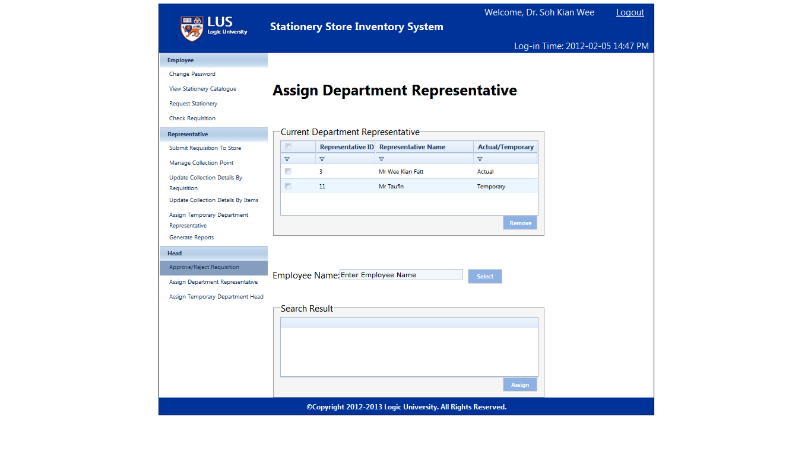

Select department representative then click “Remove”

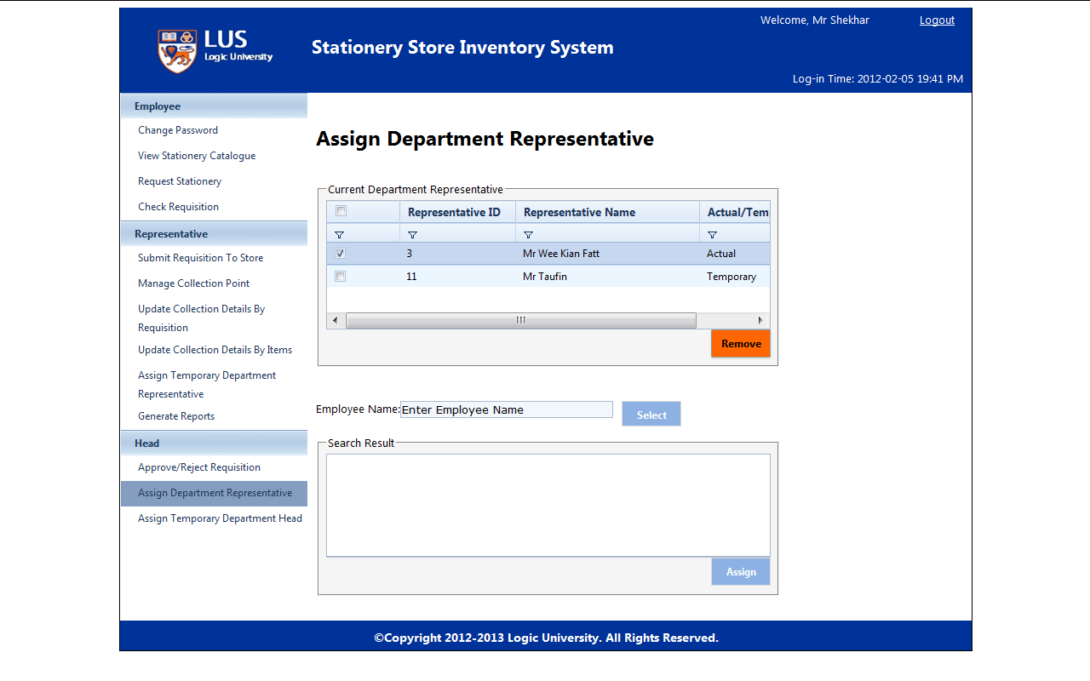

Search employee name and click “Select”

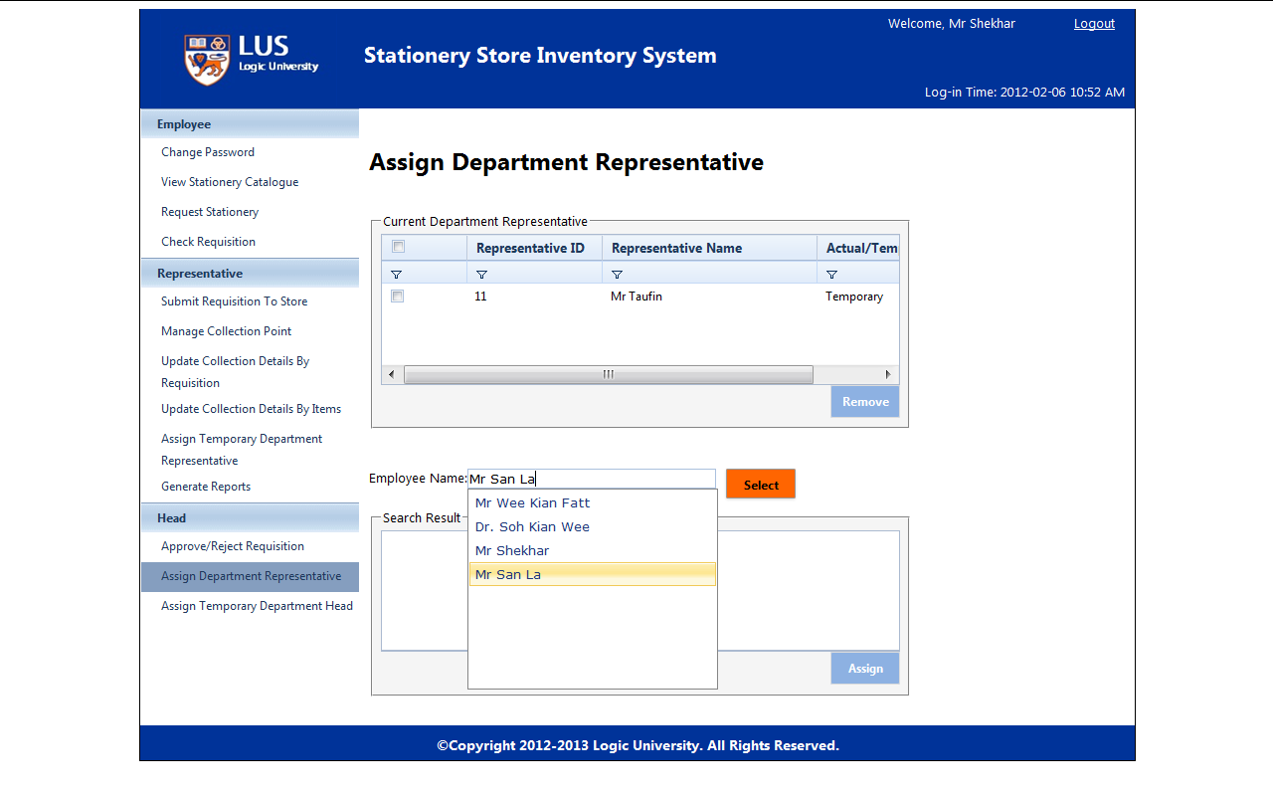

Click “Assign”, the selected employee will be assigned to be department representative.

